MA 374 (2021) Financial Engineering Lab Lab 02

**Name:** Udandarao Sai Sandeep

**Roll Number:** 180123063

**Dept.:** Mathematics and Computing

**Q1.**

With the initial values and the definitions for up-down factors (as given in the assignment), the value of the Initial Option Prices are as follows:



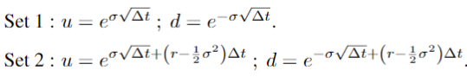

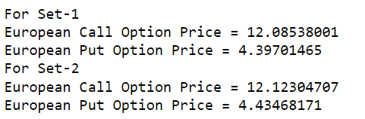

The graph of the initial option prices was observed by varying a single parameter (2-D Plots) and two parameters (3-D Plots). All possible combinations have been explored. In most of the cases, Put and Call option prices have been plotted in the same graph for better comparisons.

|  |  |  |
| --- | --- | --- |
| Set 1 | | Set 2 |
|  |  | |
|  |  | |
|  |  | |
|  |  | |
|  |  | |
|  |  | |
|  |  | |
|  |  | |

**3-D Plots: (varying two parameters at a time)**

**Green** represents European Call Option Price

**Red** Represents European Put Option Price

|  |  |
| --- | --- |
| Set 1 | Set 2 |
|  |  |
|  |  |
|  |  |
|  |  |
|  |  |
|  |  |
|  |  |
|  |  |
|  |  |
|  |  |

**Q2.**

Here, the path dependent derivative used is **Asian Option**.

The initial Asian option price was calculated as follows:

Each possible path was explored (which was required to compute the average), and hence the time complexity for finding the required option price was exponential (2M). Hence, the value of M was reduced from **100 to 10** to accommodate the high time complexities.

S(0) = 100 ; K= 100 ; T= 1 ; M= 10 ; r= 8% ; σ= 20%.

Using the above parameters, the option prices calculated are as follows:

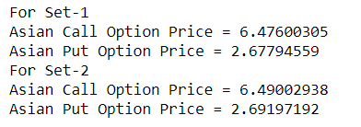

Similar to Q1,

The graph of the initial option prices was observed by varying a single parameter (2-D Plots) and two parameters (3-D Plots). All possible combinations have been explored. In most of the cases, Put and Call option prices have been plotted in the same graph for better comparisons.

|  |  |
| --- | --- |
| Set 1 | Set 2 |
|  |  |
|  |  |
|  |  |
|  |  |
|  |  |
|  |  |
|  |  |
|  |  |
|  |  |
|  |  |

**Green** represents Asian Call Option Price and **Red** Represents Asian Put Option Price

|  |  |
| --- | --- |
| Set 1 | Set 2 |
|  |  |
|  |  |
|  |  |
|  |  |
|  |  |
|  |  |
|  |  |
|  |  |
|  |  |
|  |  |